AND
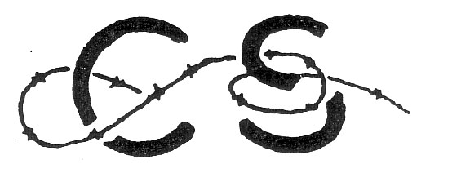CHILD SURVIVORS ASSOCIATION OF GREAT BRITAIN - AJR

REGISTRATION FORM

ANNUAL EUROPEAN CONFERENCE OF SURVIVORS
August 13 to 16, 2010

Please complete in BLOCK CAPITAL LETTERS

Family name First name

Organisation Country of birth

Home address
Street & house number

Town
Postal code
Country

Telephone
Flight number
or Eurostar
UK arrival airport/station

Arrival time

Mobile number

E-mail

Return this form by post before 1st July 2010 to
Mrs Joanna Millan,
4 Court Close
St John’s Wood Park
London
NW8 6NN
England
or by e-mail to
joanna.millan@sky.com

